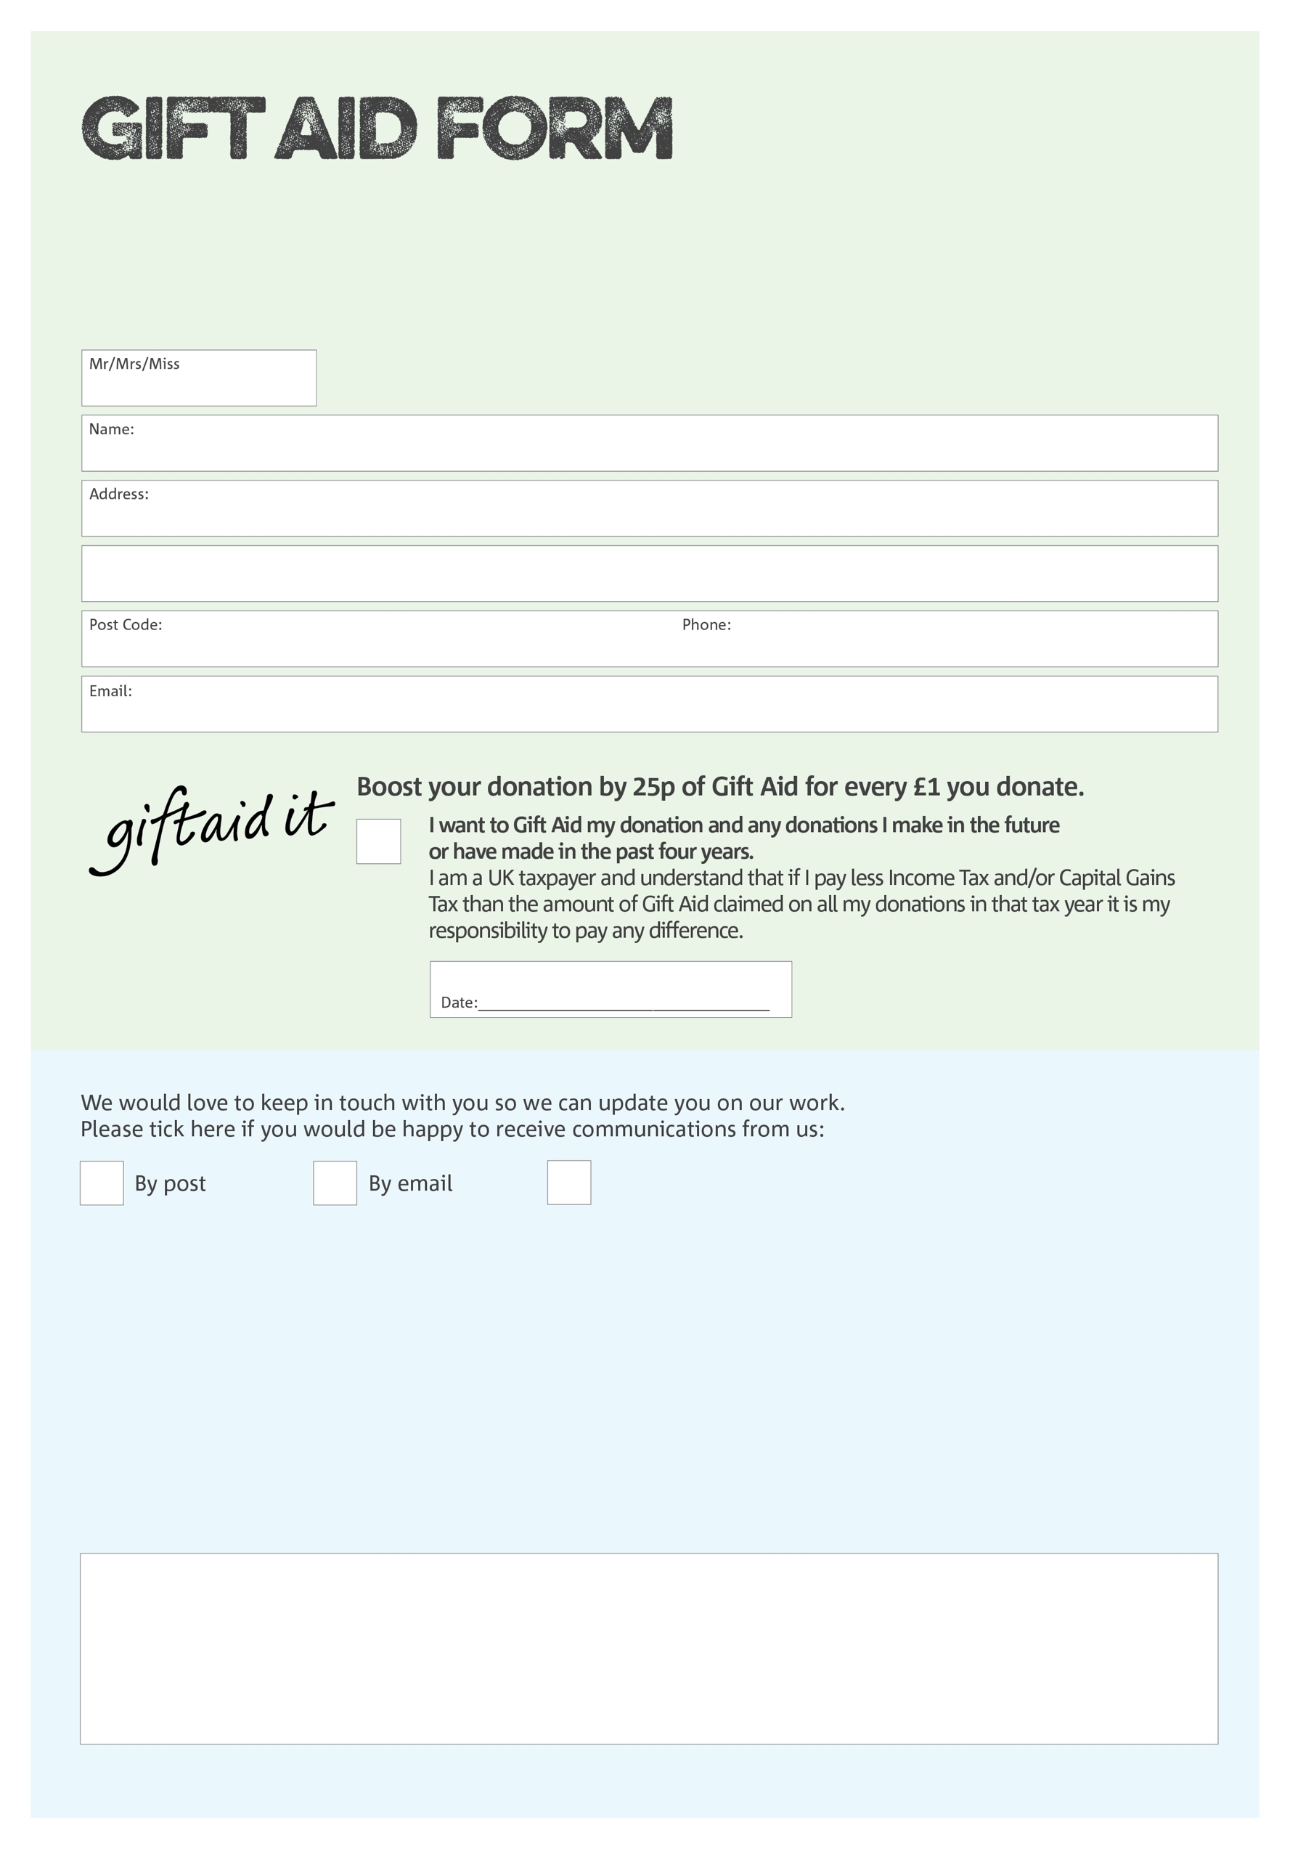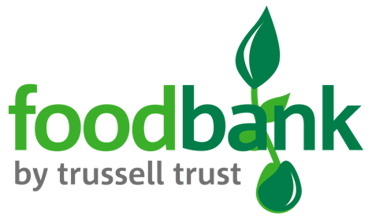

By filling in this form Leeds South & East Foodbank will receive an extra 25p for every £1 you give at no extra cost to you. Thank you!

**Data protection**

*'Leeds South & East Foodbank is committed to protecting your privacy and will process your personal data in accordance with current Data Protection legislation. Leeds South & East Foodbank collects information to keep in touch with you and supply you with information relating to our work. To unsubscribe from our newsletter, send a message to the email address above with the word unsubscribe in the subject line. A full data privacy statement for financial donors is available from the foodbank on request.’*

You can change your preferences any time by contacting us on 0113 3450850 or emailing us at

info@leedssouthandeast.foodbank.org.uk

I do not wish to receive future communications from Leeds South & East Foodbank

We would love to know why you have chosen to donate to Leeds South & East Foodbank. If you would like to share your motivation let us know below:

Charity Number 1154363. Registered in England & Wales