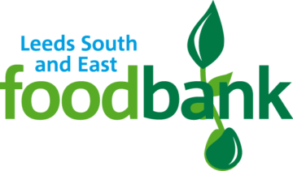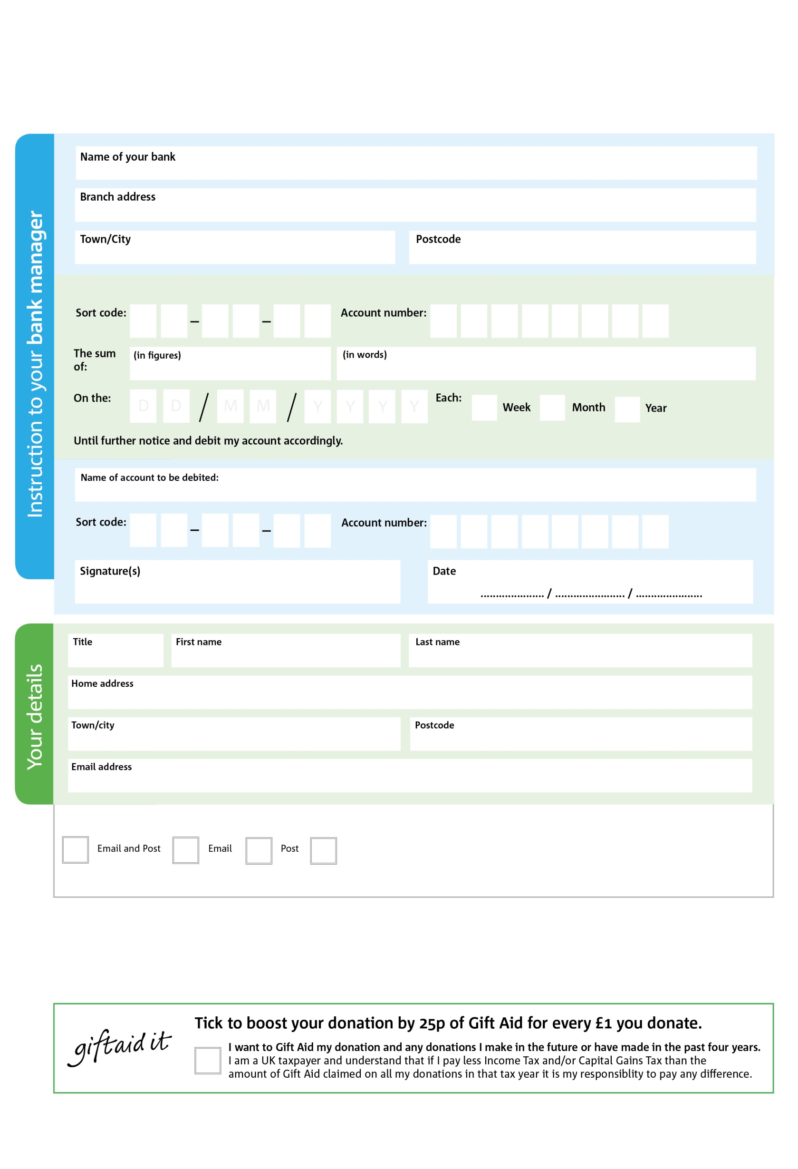

**Standing Order Mandate**

**WWW.leedssouthandeast.foodbank.org.uk**

POSTAL ADDRESS:Leeds South and East Foodbank, 7 Lenton Drive,LEEDS,LS11 5JW

Reg. Charity No: 1154363 | Reg. in England & Wales

3X

V

3X

V

8X

V

5X

V

2X

V

3X

V

0X

V

2

V

**Please pass this form onto the foodbank, using the foodbank’s address at the bottom, who will save a copy for their records.   
They will then send it onto your named bank or building society.**

1

0X

3

8

0

60

We would love to keep you up to date with information about Leeds South and East Foodbank. Please tick your preference:

You can change your preferences any time by contacting us on 0113 3450850 or emailing us at info@leedssouthandeast.foodbank.org.uk

I do not wish to receive future communications from leedssouthandeast Foodbank

Please pay Leedssouth&East foodbankFoodbank Foodbank,

**Data protection**

*'Leeds South and East Foodbank is committed to protecting your privacy and will process your personal data in accordance with current Data Protection legislation. Leeds South and East Foodbank collects information to keep in touch with you and supply you with information relating to our work. To unsubscribe from our newsletter, send a message to the email address above with the word unsubscribe in the subject line. A full data privacy statement for financial donors is available from the foodbank on request.’*

You can change your preferences any time by contacting us on XXXXXXXXXXX or emailing us at XXXX@XXXXXXXXXX.foodbank.org.uk

I do not wish to receive future communications from XXXXXX Foodbank